Intermodal and Multi-Modal Education at the University of Kentucky
John Magner ¹, Jerry G. Rose¹
¹ Department of Civil Engineering, University of Kentucky, Lexington, KY

In addition to the Railway Facilities Design and Analysis course (CE 533), the University of Kentucky Civil Engineering Department currently offers a course in Railway Operations and Multi-Modal Transportation (CE 433). The operational aspects necessary for the efficient transportation of freight and passengers by rail have always been a primary focus of the course. Over the past several years, however, the course has incorporated material related to intermodal transportation to reflect the growing importance of intermodal shipping in the United States and internationally.

Course Evolution
For years, the CE 433 course focused solely on railway operations. Topics covered in the course included train control and signal systems, the types of rolling stock and motive power, efficiency measurements, planning processes, and the types of train operations. While these topics are still included, intermodal transportation, or the concept of transporting passengers and freight on two or more different modes in such a way that all parts of the transportation process, including the exchange of information, are efficiently connected and coordinated, has also become a primary focus in the class. Initially, a unit on waterway transportation was introduced along with additional general information on Intermodal Transportation. Additional Units on Highway Motor Truck, Airline, Pipeline, and Overland Conveyor Transportation have been incorporated to provide a multi-modal course.

Current Course
The course currently dedicates half of the semester to railway operations, and half to the operations of the various other transportation modes. Including the five additional modes, along with railways, allows students to understand the advantages and disadvantages of each mode, and how coordinated movement between the different modes can form an efficient transportation network. The texts and lecture materials for the course are currently being expanded to further included information on intermodal operations, trends, and issues.
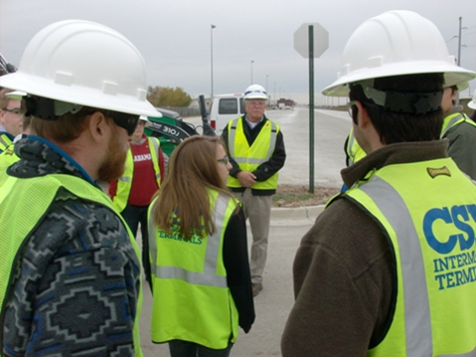Figure 1: Students visiting CSX’s intermodal yard in Louisville, KY
Beyond the Classroom
In addition to lecture material, students enrolled in the course are given the opportunity to learn through guest speakers and field trips. The speakers come from diverse backgrounds from within the different industries, and the field trips provide students a hands-on opportunity to witness the operations involved with intermodal transportation. The Fall 2014 class featured a guest lecture on river transportation by a representative from the Crounse Corporation, as well as a field trip to the Blue Grass Airport in Lexington, KY. The previous class participated in field trips to CSX’s intermodal yard in Louisville, KY and Norfolk Southern’s John Sevier yard in Knoxville, Tennessee.
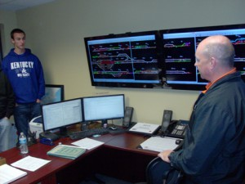Figure 2: Students observe dispatching operations at NS’s John Sevier yard

